POE Task 1

OPSC7311

|  |  |  |
| --- | --- | --- |
| **GROUP 17** | | |
|  | **Student Number** | **Full Name** |
| 1 | ST10090464 | Phakeme Sithole |
| 2 | ST10090974 | Sean Maseola |
| 3 | ST10090957 | Nhlanhla Maseko |
| 4 | ST10091114 | Siyabonga Zunguza |
| 5 | ST10091140 | Simphiwe Manaba |
| 6 | ST10091204 | Samir Ramkisson |
|  | **Lecturer** |  |
|  | **Module** | **Full Name** |
|  | OPSC7311 | SAMUEL CHIKASHA |

Contents

Introduction 6

Research part 1a 6

My Hours 7

Overview 7

Strengths and weaknesses 10

Strengths 10

Weaknesses 10

Innovative Feature 11

Clockify 11

Overview 12

Strengths and Weaknesses 14

Strengths 14

Weaknesses 14

Innovative Feature 15

Connecteam 16

Overview 17

Strengths and Weaknesses 18

Strengths 18

Weaknesses 18

Innovative Feature 19

Visual Infographic 21

List of Taken Features 22

Conclusion 22

Introduction 24

Overview 24

list of the innovative featureS 25

Requirements 25

User interface design 25

User interface Diagram 39

Modular diagrams of the User interface 40

Diagrams 40

Project Plan Gantt Chart 48

Conclusion 48

POE PART 1 A REFERENCES 50

My Hours References 50

Clocify References 50

Connecteam References 51

Infographic References 51

POE PART 1B REFERENCES 52

Research

# Introduction

To be able to track one’s work progress and manage their time, applications have been developed to do exactly that. These applications provide goal creation, progression monitoring, and more. Research has been conducted on three time-tracking applications that do exactly that. The Time tracking applications that were researched are “My hours”, “Connecteam” and “Clockify”. “My Hours” is an application that allows the user to track various projects in an organized manner within a business, this application allows the user to track how much time they spend working on different projects. (myHours, 2022.) The application offers additional features such as flexible billing for projects and custom reports. It is easy to use for individual and team projects. Users can check their progression with relative ease by checking how on they spend on certain projects. (myHours, 2022) The Clockify application uses a robust time-tracking platform that excels in project tracking to help companies stay on track and under budget. The application provides offline functionality which allows employees to use the application at any time and any location. (Hale,2023) Connecteam helps with monitoring regular work shift hours, double hours, and overtime, which can all be highly customized to fit the user’s needs. Connecteam can also help with mileage read, equipment usage, or any other information necessary to issue with payrolls. (Connecteam, 2023)

# Research part 1a

## My Hours

### Overview

Users can track time spent on projects for tasks, they can create in-depth reports, and send invoices to their clients. It allows its users to create projects which have descriptions such as name, clients, and hourly rate. This allows team members to finish their work in a timely manner and allows the manager to see the hours worked for payments. (myHours, 2022.) Tasks have descriptions such as name, which project it falls under, team members involved, and start and end dates. My Hours’ project and task features meet two functional requirements. These two requirements are “user must be able to create categories” and “user must be able to create entries for the categories.” Categories being projects and entries being tasks. (myHours, 2022)

**(Fig. 1 Mobile Time Tracking)** (myhours.com, 2022)

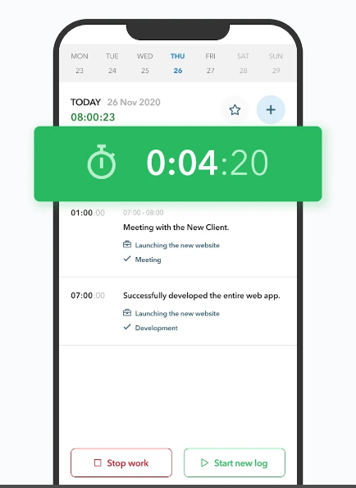

**(Fig. 2 Organize With Project and Tasks)** (myhours.com, 2022)

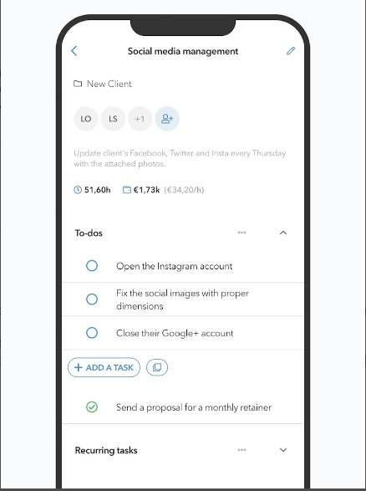

The “My Hours” application offers a graphical display that shows the user how long teams have spent on certain projects, clients, and tasks. The graph also displays Billable Amount which shows users financial information in an easy-to-understand format. With this feature, “My Hours” meet one of the requirements which is, “user must be able to view graph.” (myHours,2022)

**(Fig. 3 Mobile Time Reporting)** (myhours.com, 2022)

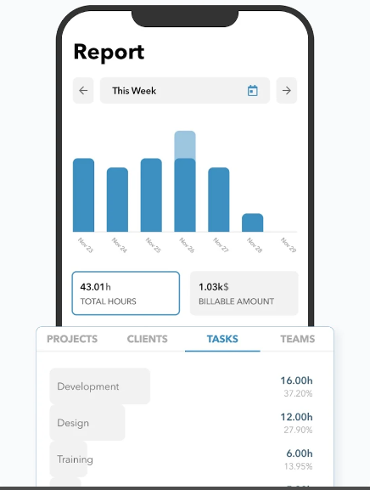

My Hours also possess an account system. Users logs into their account using their username and password. In addition, “My Hours” has the option to invite other users of the application to join their team. After joining the team, admin/lead can assign task from projects for the different members to complete. This meets the log in requirement which is, “user must be able to log in.” (myHours, 2022)

My Hours displays the total hours spent on a project weekly, monthly, or yearly. Users can see how long they spent working on projects and if they met their goals or not. With this feature, “My Hours” checks off the requirement of, “user must be able to view the total number of hours spent on each category.” (myHours, 2022)

**(Fig. 4 Set Billable Rates)** (myhours.com, 2022)

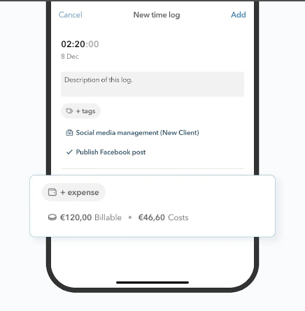

### Strengths and weaknesses

**Strengths**

* Unlimited team members and projects
* Manual Time Tracking
* Powerful Reporting
* Tracking Billable Hours
* User Friendly UI

(My hours reviews, Page 6: My hours reviews - pros &amp; cons, ratings &amp; more,)

**Weaknesses**

* Paid wall for more features
* Text is hard to read on some devices
* Some advanced web features not integrated into mobile version

(My hours reviews, Page 6: My hours reviews - pros &amp; cons, ratings &amp; more)

**(Fig. 5 Keep Up With Reminders)** (myhours.com, 2022)

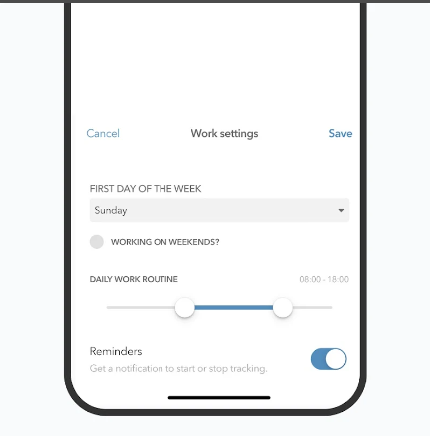

### Innovative Feature

* Tracking Time to Project/Task:
  + Users can create projects and those projects can have tasks. These tasks are specific to certain projects and completing them leads to progression for said projects. Tasks can be further ordered into tasks list. (myHours, 2022; Play store, 2002)
* Filtering:
  + Users can filter the graph and reports by projects, tasks, clients, and team members. This filtering makes management for team leaders significantly easier, especially if they oversee multiply projects.
* Team Management:
  + Team leaders use “My Hours” to manage their team to make sure the team is meeting their deadlines. They can approve and comment on team member’s time logs. (myHours, 2022; Play store, 2002)

## Clockify

### Overview

With Clockify, users can view activities of the current day as well as ones from the previous day. Each activity has a tag to show the current state of said activity and the duration for it. Next to the duration it is recorded how much time that activity will last and shows the total hours that were spent for all activities in the top right. Users can also create new activities for the current day. (Hale, 2023; Beasley & Vallescas, 2023).

Clockify has a side tab that will allow users to jump between different views. To track their progress, “Users simply start the timer from any device when they begin work on a new or existing project” (Hale, 2023; Beasley & Vallescas, 2023).

**(Fig. 6 Clockify Homepage)** (play.google.com, 2017)

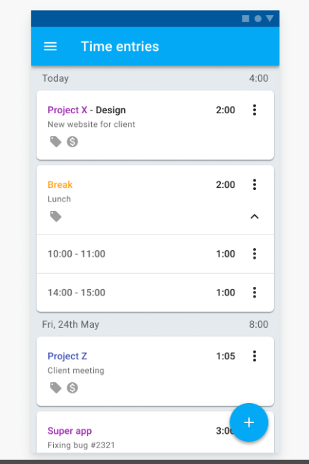

Clockify displays all the activities that are in progress and completed in an auto generated graph that shows user progress for the week and total hours. This can be further filtered to day or month. It also colour-codes each activity to visual separate them from each other like in the above example. (Hale, 2023; Beasley & Vallescas, 2023)

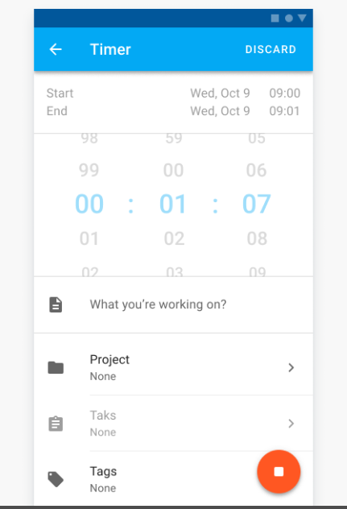

**(Fig. 7 Timer for Tracking)** (play.google.com, 2017)

Clockify can also create calendars that are designed around the projects and activities the user created. It also shows the current status of activities that are in progress and helps managing multiple activities. (Hale, 2023; Beasley & Vallescas, 2023)

This screenshot shows how Clockify allows users to input hours they want to spend on certain projects for the week. In addition, it also shows the totals hours for both the day and week. (Hale, 2023; Beasley & Vallescas, 2023).

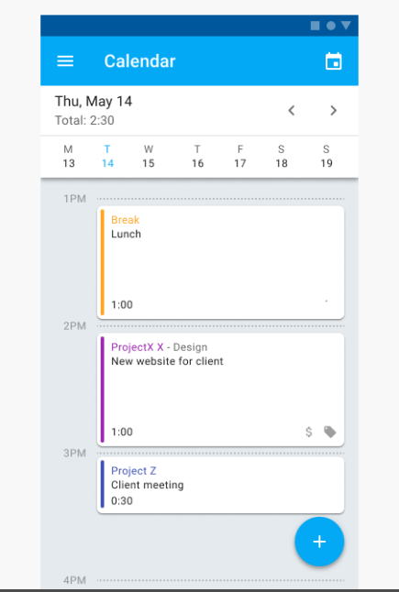

**(Fig. 8 Task Progress of the Day)** (play.google.com, 2017)

### Strengths and Weaknesses

**Strengths**

* Easy to use
* Project and activity tracking
* Auto tracking
* It can accommodate any business size and can also be scaled.
* It can be used on any platform
* It can also be integrated with apps and other software
* It also allows other users to join in and form a collaborative schedule

(Hale, 2023; Beasley & Vallescas, 2023).

**Weaknesses**

* The process to setup
* Lack of robust scheduling can be limiting
* Having to clock in and out can be quite tedious and drop work efficiency
* To have full access to the entire abilities of Clockify, you do need to pay for the premium bundles.

(Hale, 2023; Beasley & Vallescas, 2023).

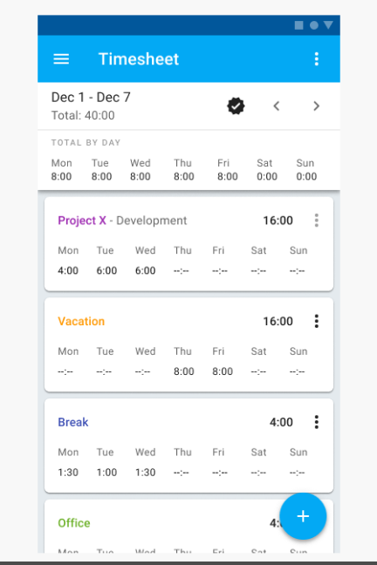

**(Fig. 9 Entering Time In Timesheet)** (play.google.com, 2017)

### Innovative Feature

* Time Assigning:
  + Allows the user to enter the hours daily for a week and shows the total hours for the day and the week
* Activity Monitoring:
  + Can monitor the status of hours of any activity you are currently doing and constantly update the status as the time progresses
* User Tracking:
  + Has a clock-in and clock-out feature which will create a log of when you use and exit the app
* Offline Data log:
  + Has the capability to work offline and then sync up any changes when connecting back to the internet
* Notifications:
  + When using the app on a mobile device, the app will send reminders about tasks and warn you for time idling
* Ease of Use:
  + It can scale to the needs of the business, it has cross platform capabilities, and it has a built-in timer.(Hale, 2023; Beasley & Vallescas, 2023; Coing, 2017)

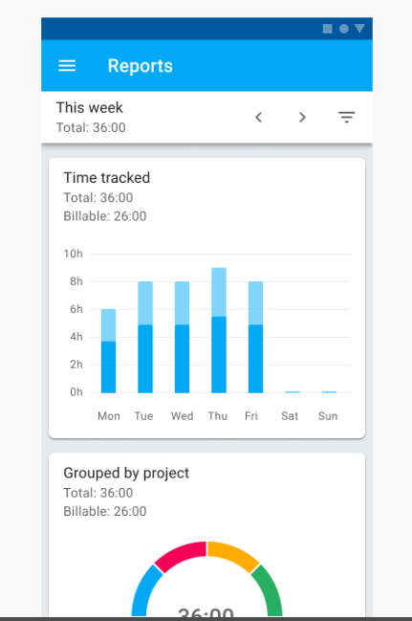

**(Fig. 10 Time Tracked Graph)** (play.google.com, 2017)

## Connecteam

### Overview

Connecteam offers users a GPS time clock that can be accessed from any mobile device. It can be used to track time spent on work hours, jobs, or projects. It is designed especially for non-desk users, is easy to use and requires no training, and can be used for multiple employees. (Time Clock App, 2023; Connecteam.com, 2023)

**(Fig. 11 GPS Tracking of Members)** (play.google.com, 2016)

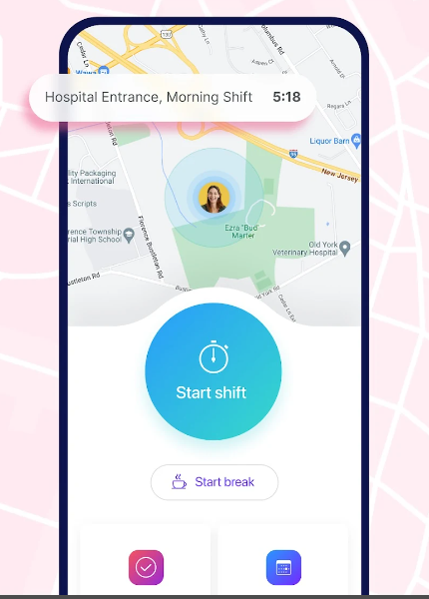

Connecteam can also help with mileage read, equipment usage, or any other information necessary to issue payrolls. It also has an integrated in-app chat and easy-to-use timesheets, which makes the payroll process faster. Connecteam allows user who are non-desk employees to use a clock-in and clock-out features when they are moving from location to location. (Time Clock App, 2023; Connecteam.com, 2023)

**(Fig. 12 Goal Progress and Work Schedule)** (play.google.com, 2016)

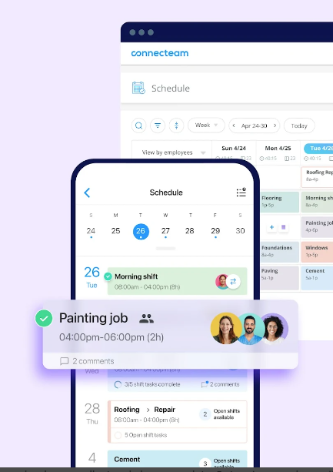

### Strengths and Weaknesses

**Strengths**

* Has a variety of options to configure and customize how you want your team to work together.
* Has a great interface that allows the user to manage their team from one dashboard.
* All employee information is displayed in one place to prevent misunderstandings or lost productivity due to miscommunication between co-workers.
* User can assign tasks directly from their dashboard so there is no need for emails or other forms of communication.
* Users can add their own documents and files from any device on the network so that they can be shared easily with other members of the organization through the app’s group chat.
* All-in-one software for employee management.
* Efficient employee time tracking

(Iwuozor, J. 2023; McCabe, L., 2022; S, *Total security LLC - Connecteam* 2023).

**Weaknesses**

* Users are frequently prompted to upgrade to access extra features.
* Pricing for teams of less than 30 users is expensive.
* Application lags and app freezes occasionally.
* App can freeze at random times for hours

(Gerard S. 2023; Iwuozor, J. 2023; S, *Total security LLC - Connecteam* 2023).

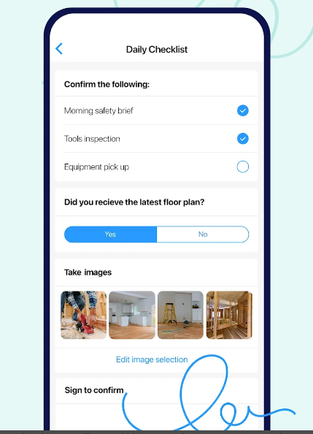

**(Fig. 13 Complete Reports for Projects)** (play.google.com, 2016)

### Innovative Feature

* GEOFENCING LOGIN TRACKING,
* Get notification when employees are late
* Timesheet Payroll
* GPS Tracking
* Work from Home Log in
* Time Calculation
* Automatic Reporting

(Connecteam.com, 2023; McCabe, L., 2022).

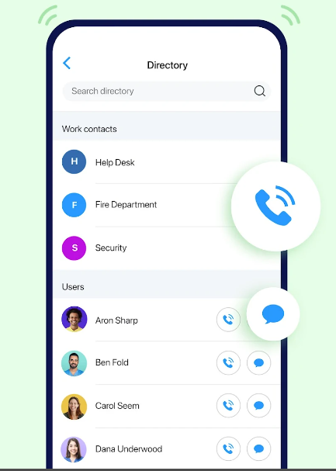

**(Fig. 14 Easily Contact Members)** (play.google.com, 2016)

myHours 2022.)

# Visual Infographic

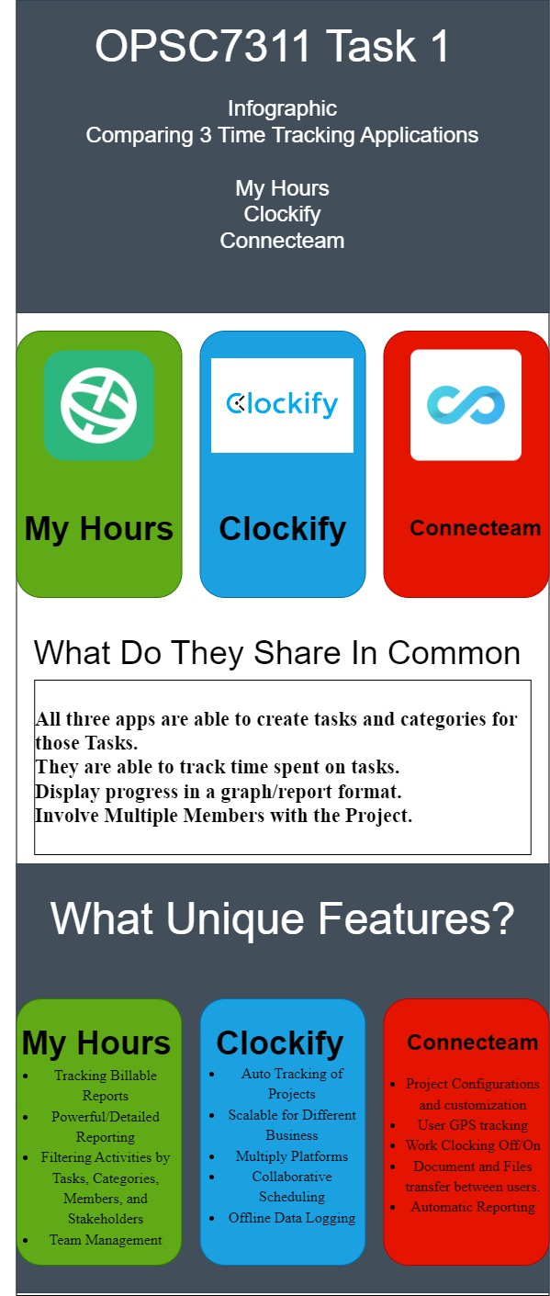

**(Fig.15 Visual Infographic comparison of researched Time Tracking Apps)**

# List of Taken Features

* The app must display in a visual format all the information they need such as how long they have worked from all entries and how well the user is doing with staying between their minimum and maximum hour goals over the past month by using a middle line in a line graph that has two lines representing the minimum and maximum hours just like the Connecteam and the Clockify App so that they can see if they over-performing and working for hours they will not be paid for or if they are under-performing and working less than the minimum hours for the day.
* The application will send out notifications to users to inform them if they have reached the minimum and maximum working hours for the day as well as notifications that will tell them if they are not spending enough time on other categories of the projects, so that it can be easy for them to stay in between the minimum and maximum hours and not neglect other categories.
* Employees must have the option to use filtering to make it easier for them to find different dates worked on when they are looking at their entries just like the myHours Application.
* The application will calculate how much a user will get for each day after multiplying the number of hours with the hourly rates just like the Connecteam app so that employees can know how much they should be getting paid every month.
* The application must have very descriptive graphs like all the applications so that users can find it very easy to extract information such as how long they work for on each category with ease.
* Data must be stored in an online database so that information is not lost every time the employee logs out of the application.

# Conclusion

Even though some Time Tracking applications have great functionalities and features, they still fall short in making the user interface easy to read, they are difficult to navigate through and they are not easy to use on all devices, they frequently prompt users to make updates, their application lags occasionally and are sometimes very expensive to use if you want to use all their features. (My hours reviews; Page 6: My hours reviews - pros &amp; cons, ratings &amp; more) We will be introducing an application named Second Sense that will have the innovative features from the “List of Taken Features” from the researched applications as well as features such as enabling users to add a images and descriptions to timesheet entries, the application will be able to move from light to dark mode. The application will perform all the basic functions of other Time Tracking Apps such as enabling users to log in and out of the app and create accounts. Second Sense will have its own innovative features such as gamification because we have seen that Time Tracking Apps do not have that and we believe that it will help users with engaging with the application and keep them from being distracted by anything outside the application. (myHours, 2022; Connecteam.com, 2023; McCabe, L. 2022)   
[1880 WORDS]

Planning and Design

# Introduction

We have taken the time to research different time tracking applications, and with all the data that was collected we have created an application called Second Sense which is a Time tracking application that has a combination of the best innovative features from the “My hours”, “Connecteam” and “Clockify” applications, as well as its own features. Unlike other applications “Second Sense” includes gamification to keep the users engaged with the application and it allows users to make entries based on the User’s goals

## Overview

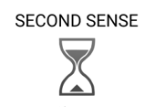

**(Fig. 16 App Icon and Name)**

## list of the innovative featureS

* The application will display the progress of the user based on the minimum and maximum hours set, and will be notified if they are under-preforming or over-preforming.
* The application will notify the user for goals completed, failure to adhere to goals, milestones, etc.
* The application will allow user to filter through all their tasks and projects, either based on type, stockholder, dates, or project status.
* The application will calculate for the user the amount owed to them based on their work hours and hourly rate.
* The application will have a detailed graph on what the user’s progress.

## Requirements

* The employees must be able to log in to their own account with their username and password.
* The employees will be able to create categories that will hold entries that are specific for that category.
* The employee will be able to create entries inside an already existing category.
* The employee will be able to add an image to display on an entry.
* The employee will be able to set a min-and-max Hours daily goal for themselves.
* The employee will be able to see a list of all their entries and click on any of them to display its details.
* The employee will be able to view total hours spent on each category.
* The employee will have access to a graph that will display data based on the user categories and entries.
* A line graph will be used to display the user’s progress based on the min-and-max hour goals to see if the user is on track.
* The user data will be stored in an online database so it is not lost.
* The employee will be able to toggle form light or dark theme for the display.
* The employee will receive notifications indicating when they have reached the minimum or maximum goal, as well as notifying them on categories that have been neglected.
* The employee will be able to use filtering to search through their entries with less effort.
* The employee will be able to create their own accounts.
* The employee will be able to see the amount owed based on the calculations of hourly rate and work done.

Within the “User Interface Design” section, the requirements and features are gone into more details.

## User interface design

|  |  |
| --- | --- |
|  | **(Fig. 17** **Home Screen)**    **Functional requirement:** The app must display in a **visual forma**t how well the user is doing with staying between their minimum and maximum hour **goals** over the past month    Options (Icon indicated by 3 lines): Will pull up an options menu and the user will be able to choose between: User setting, themes, Etc    Top panel: The top panel has a list of the available for the user to navigate to.    Create button: Will add a new entry or a new category.    Previous records: these will be the time entries that the user had made previously, the user will be able to view its details by clicking on the record.    Min/Max hours, will display the number of hrs the user has done for the day and if they have reached their min or max threshold for that day.    Weekly graph: This will display the total hours that the user has recorded for that week. |
|  | **(Fig. 18 Categories Screen)**  Create button:  Will create a new category    **Functional requirement**: The user must be able to view the **total number** of hours spent on each **category** during a **user selectable period**.    Category List: This will be a list of all created categories; the user will see a category title and the number of hours spent on a certain category. |
|  | **(Fig. 19** **Sign-up screen)**    Sign-up screen: user will be able to create an account. The user will enter their details and click the sign-up button. |
|  | **(Fig. 20** **Login screen)**    **Function Requirements:** The user must be able to **log in** to the app using a username and password.      Login Page: The user must have created an account and entered the correct details to login. |
|  | **(Fig. 21** **Timesheet entries screen)**    **Functional requirement**: The user must be able to view the **list** of all the timesheet entries created during a **user selectable period**. If a **photo** was stored for an entry, the user must be able to **access** it fromthis list.    Entry screen: when a user clicks on one of the entries tab, a list of entries will be viewable and the user will be able to choose a selectable time period and view the entries made with in that selected time.    The total hours done with in that selected period will be written below.    Create button: The user can create new entries by clicking this button. |
|  | **(Fig. 22** **Entries screen for a specific Category screen)**    **Functional requirement**: The user must be able to view the **list** of all the timesheet entries created during a **user selectable period**. If a **photo** was stored for an entry, the user must be able to **access** it fromthis list.      On the Categories screen there will be a list of categories that the user had created, upon clicking on one of the items on that list, the system will display all the entries that had been made for that specific item.    Create button: the user can create a new entry for the selected category.    The total hours done with in that selected period will be written below.    Result filter: The user can choose a specific time period to filter the results, and the system will only show entries that were made during that time. |
|  | **(Fig. 23** **Analytics screen)**    This screen is primarily used for tracking the rate in which your project is progressing.  You can select a specific project so that a graph will only show information on that project alone, and you can choose to see the progress of that day, that week, or that month using the buttons above the graph.    **Functional requirement**: The user must be able to view a **graph** showing the **total hours worked** each day over a user selectable period. The graph must also display the **minimum and maximum goals.**    Goals button: The button that is titled Goals is for setting the minimum or the maximum goals for a project. |
|  | **(Fig. 24** **Create timesheet entry screen.)**    **Functional requirement**: The user must be able to **create a timesheet entry**, specifying at least the date, start and end times, description, and category.    New entry screen: Upon choosing a category to create an entry for, the system will display this screen. The user can enter the entry details and click done to save and record the entry.    Attach button: Allows the user to attach a picture to the specific entry being created.    Start and end time: The inputs will pull up date time pickers which will only let the user choose hours and minutes. |
|  | **(Fig. 25** **Add photo screen.)**    **Functional requirement**: The user must be able to optionally add a **photograph** to each timesheet entry.    Picture screen: This screen is to add a picture to any entry you want to create. You can access it from the new entry screen.    Add button: This is to allow you to choose a picture from your own gallery.    Cancel button: To cancel the entire picture process.    Done: To signify the completion of this process. |
|  | **(Fig. 26** **Add photo screen.)**    **Functional requirement**: The user must be able to create **categories** that the timesheet entries will belong to.    New Category screen: This screen will be for creating new categories, providing them with a name and a description. |
|  | **(Fig. 27** **Entry details screen )**    Entries Details Screen: This is just to review everything that has been done to create a new entry and the category that it is linked to. |
|  | **(Fig. 28** **Settings screen )**    Options (Icon indicated by 3 lines on home screen): Will pull up an options menu and the user will be able to choose between: Goals, themes, Etc |

**Pop-ups**

|  |  |
| --- | --- |
|  | **(Fig. 29** **Choose a category screen)**    This lets you choose categories that have already been created. It will pop up when a user chooses to create a new entry.    New button: This button is one of the ways in which a new category is created outside the entry screen. |
|  | **(Fig. 30** **Min/Max Hours screen)**  The purpose of this screen is to set the minimum and maximum hours.    **Functional requirement:** The user must be able to set a **minimum** daily goal for hours worked, as well as a **maximum** daily goal. |
|  | **(Fig. 31** **Filter Custom)**  To filter results when looking for specific entries in a list between a specific period. |

## User interface Diagram

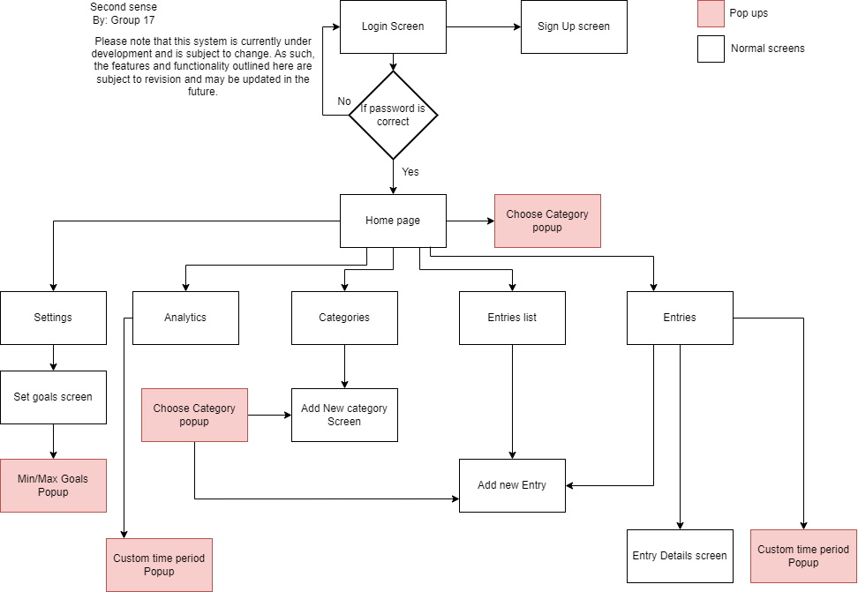

## Modular diagrams of the User interface

|  |  |
| --- | --- |
| Diagrams |  |
| **(Fig. 32** **Logging in** ) |  |
| **(Fig. 33 Creating a category)** |  |
| **(Fig. 34** **Create a time sheet entry)** |  |
| **(Fig. 35** **Add an optional photograph )** |  |
| **(Fig. 36** **Add minimum and maximum daily goals** ) |  |
| **(Fig. 37** **List of all the timesheet entries, and be able to access photo )** |  |
| **(Fig. 37**  Total number of hours spent in a certain category) |  |
| **(Fig. 37** graph showing the total hours worked) |  |

## Project Plan Gantt Chart

**(Fig.38 Gant Chart)**

## Conclusion

The **Second Sense** application has incorporated the best features from all the researched applications and has improved on were most Time Tracking Applications have weaknesses. It can make users enter entries and categories just like Connecteam but has its own innovative features added to that by being able to add pictures and descriptions to those entries. Employees can view selectable time periods like Clockify but are also able to view everything in various types of graphs to help users analyse their entries of a long period of time much easier. Employees using Second Sense can track the time spent on different aspects of the project and get notifications on how much they would get each day for time that was spent working. Second Sense uses gamification to keep users engaged with the application and not distracted by anything outside the application. These are some of the things we believe Time Tracking Applications that will be created after this one should incorporate as well in order to satisfy more users.

[1590 WORDS]

# *POE PART 1 A REFERENCES*

## *My Hours References*

[*https://myhours.com/*](https://myhours.com/)

*Official Website*

*Reference: myhours.com. (n.d.). Free Time Tracking for your Projects and Tasks | My Hours. [online] Available at: https://myhours.com/.*

[*https://play.google.com/store/apps/details?id=com.myhours.Spica_MyHours&hl=en&gl=US*](https://play.google.com/store/apps/details?id=com.myhours.Spica_MyHours&hl=en&gl=US)

*Playstore. “Spica My Hours - Apps on Google Play.” Play.google.com, play.google.com/store/apps/details?id=com.myhours.Spica_MyHours&hl=en&gl=US. Accessed 17 Mar. 2023.*

*https://www.softwareadvice.com/za/project-management/myhours-profile/reviews/*

*Pros and Cons*

*My hours reviews (no date) My Hours Software Reviews &amp; Ratings | 2023 | Software Advice. Available at: https://www.softwareadvice.com/za/project-management/myhours-profile/reviews/ (Accessed: March 17, 2023).*

[*https://www.getapp.com/project-management-planning-software/a/my-hours/reviews/page-6/*](https://www.getapp.com/project-management-planning-software/a/my-hours/reviews/page-6/)

*Pros and Cons*

*Page 6: My hours reviews - pros &amp; cons, ratings &amp; more (no date) GetApp. Available at:* [*https://www.getapp.com/project-management-planning-software/a/my-hours/reviews/page-6/*](https://www.getapp.com/project-management-planning-software/a/my-hours/reviews/page-6/) *(Accessed: March 17, 2023).*

*(Page 6: My hours reviews - pros &amp; cons, ratings &amp; more)*

## *Clocify References*

*Hale, J. (no date) Clockify Review and pricing in 2023, business.com. Available at: https://www.business.com/reviews/clockify/ (Accessed: March 12, 2023).*

*Vallescas, J. (2022). Clockify Review: Is It the Right Time Tracking Software for You? [online] Fit Small Business. Available at:* [*https://fitsmallbusiness.com/clockify-review/#:~:text=Clockify%20earned%20the%20top%20spot%20on%20our%20list*](https://fitsmallbusiness.com/clockify-review/#:~:text=Clockify%20earned%20the%20top%20spot%20on%20our%20list) *[Accessed 12 Mar. 2023*

*Inc, C. (n.d.). Clockify - The #1 time tracker for teams. [online] Clockify. Available at:* [*https://clockify.me/feature-list#features-apps*](https://clockify.me/feature-list#features-apps) *[Accessed 12 Mar. 2023].*

*play.google.com. (2017). Clockify Time Tracker - Apps on Google Play. [online] Available at: https://play.google.com/store/apps/details?id=me.clockify.android&hl=en&gl=US [Accessed 20 Apr. 2023].*

## *Connecteam References*

*Time Clock App (0) (2023) Connecteam. Available at: https://connecteam.com/employee-time-clock-app/?homeFeatureSlide=true (Accessed: March 18, 2023).*

*Iwuozor, J. (2023) Connecteam Review (2023): Features, Pros & Cons, Forbes. Forbes Magazine. Available at: https://www.forbes.com/advisor/business/connecteam-review/* *(Accessed: March 18, 2023).*

*Connecteam.com (2023) Employee Time Tracking app for Deskless employees, Connecteam. Connecteam.com. Available at: https://lp.connecteam.com/top-time-tracking-app-aw/?utm_source=google&utm_medium=cpc&utm_campaign=s_en_za_timetrackingapp_e_desktop&utm_term=app+to+track+hours+worked&utm_content=596949118294&utm_campaignid=12459677657&utm_group=133791532742&utm_matchtype=e&utm_kwid=kwd-302157197513&utm_accountid=3625606301&gclid=Cj0KCQiAjbagBhD3ARIsANRrqEuv6EAEYjGULFHptyGXNxaweaGlpqi_z9TRcMalvJcHUvaL2cyPitMaAjvHEALw_wcB (Accessed: March 18, 2023).*

*McCabe, L. (2022) Connecteam's management solution for deskless workers is now free for small businesses with 10 or fewer employees - SMB Group, SMB Group - Actionable SMB market insight. Available at: https://www.smb-gr.com/blogs-laurie-mccabe/connecteams-management-solution-for-deskless-workers-is-now-free-for-small-businesses-with-10-or-fewer-employees/ (Accessed: March 18, 2023).*

*S, G. (2023) Total security LLC - connecteam, GetApp. Available at: https://www.getapp.com/hr-employee-management-software/a/connecteam/reviews/9890bbfa9a/ (Accessed: March 18, 2023).*

*play.google.com. (2016). Connecteam - All-in-One App - Apps on Google Play. [online] Available at: https://play.google.com/store/apps/details?id=com.connecteamco.Connecteam.app&hl=en&gl=US [Accessed 20 Apr. 2023].*

## *Infographic References*

*Time Clock App (0) (2023) Connecteam. Available at: https://connecteam.com/employee-time-clock-app/?homeFeatureSlide=true (Accessed: March 20, 2023).*

*Connecteam.com (2023) Employee Time Tracking app for Deskless employees, Connecteam. Connecteam.com. Available at: https://lp.connecteam.com/top-time-tracking-app-aw/?utm_source=google&utm_medium=cpc&utm_campaign=s_en_za_timetrackingapp_e_desktop&utm_term=app+to+track+hours+worked&utm_content=596949118294&utm_campaignid=12459677657&utm_group=133791532742&utm_matchtype=e&utm_kwid=kwd-302157197513&utm_accountid=3625606301&gclid=Cj0KCQiAjbagBhD3ARIsANRrqEuv6EAEYjGULFHptyGXNxaweaGlpqi_z9TRcMalvJcHUvaL2cyPitMaAjvHEALw_wcB (Accessed: March 18, 2023).*

*Google Play (2023) Available at: https://play.google.com/store/apps/details?id=com.connecteamco.Connecteam.app&hl=en_ZA&gl=US (Accessed: March 18, 2023).*

*Google Play (2023) Available at:https://play.google.com/store/apps/details?id=me.clockify.android&hl=en&gl=US (Accessed: March 20, 2023).*

*Google Play (2023) Available at:* [*https://play.google.com/store/apps/details?id=com.myhours.Spica_MyHours&hl=en_US*](https://play.google.com/store/apps/details?id=com.myhours.Spica_MyHours&hl=en_US) *(Accessed: March 20, 2023).*

*MyHours(2023) Available at:* [*https://myhours.com/mobile-time-tracking-app*](https://myhours.com/mobile-time-tracking-app) *(Accessed: March 20, 2023).*

*Connecteam (2023) Available at: https://connecteam.com/?utm_campaignid=16491077422&utm_group=134549115816&utm_matchtype=e&utm_kwid=kwd-383213525661&utm_accountid=3625606301&utm_term=connecteam&utm_campaign=s_en_za_brand_e_desktop&utm_source=google_brand&utm_medium=cpc&utm_content=586138973421&hsa_acc=3625606301&hsa_cam=16491077422&hsa_grp=134549115816&hsa_ad=586138973421&hsa_src=g&hsa_tgt=kwd-383213525661&hsa_kw=connecteam&hsa_mt=e&hsa_net=adwords&hsa_ver=3&gclid=CjwKCAjwq-WgBhBMEiwAzKSH6Npw2ihXPn0UlfQjUimW3QBr9JcPTpXcY92ZZnGH3CYoumke3_44RBoCMBgQAvD_BwE (Accessed: March 20, 2023).*

[*Myhours*](Myhours) *(2023) Available at:* [*https://myhours.com/*](https://myhours.com/) *(Accessed: March 20, 2023).*

[*Myhours*](Myhours) *(2023) Available at:* [*https://myhours.com/mobile-time-tracking-app*](https://myhours.com/mobile-time-tracking-app) *(Accessed: March 20, 2023).*

# *POE PART 1B REFERENCES*

*Zunguza, S. and Manaba, S. (2023) The Collaborative Interface Design Tool., Figma. Available at:* [*https://www.figma.com/*](https://www.figma.com/) *(Accessed: April 22, 2023).*